

Booklet for
Wellbeing

Local and national organisations and apps to help people find support for their wellbeing

Contents
Organisations 4
Citizens Advice Wirral 4
The Whitechapel Centre 4
Involve Northwest 4
Compañeros 5
Everyturn Mental Health 5
Tomorrow’s Women Wirral 5
Wirral Mind 5
Wirral Change 6
Wirral Multicultural Organisation 6
Liverpool Irish Centre 6
Heart 4 Refugees 6
Wirral Age UK 7
Wirral Carers Alliance 7
Wired 7
Healthwatch Wirral 7
The Lullaby Trust 8
Koala 8
Sands 8
PANDAS 8
Wirral Women and Children’s Aid 9
ItsNeverOk 9
Refuge 9
Family Safety Unit 9
Autism Together 10
Alzheimer’s Society 10
CMAGIC 10
SWITCHBOARD 10
The Martin Gallier Project 11
Hoarders Helping Hoarders 11
Pauls Place 11
WEB Merseyside 11
Wirral Ways To Recovery 12
UK Narcotics Anonymous 12
UK Cocaine Anonymous 12
Drug Talk 12
Gamblers Anonymous - Birkenhead 13
Alcoholics Anonymous 13
MEN TOO 13
James’ Place 13
Blue Cross 14
Cruse Bereavement Support 14
OCD Action 14
Sole Survivor - PTSD Support 14
Samaritans 15
Asto 15
Sahir House 15
RASA 15
A Better Life Wirral 16
Wirral Brough Council 16
EPP 16
Wirral Lifelong Leaning Service 16
Wirral WEN 17
CWP Adult Mental Health 17
Children and Young People's Mental Health Services (CYPMHS) 17
Charlotte’s Brightside 17
The Hive 18
Branch 18
The Positivitree 18
Comics Youth 18
The Hub of Hope 19
Smiling Mind 19
Move Mood 19
Useful websites and apps 20
Sleepio 20
Clear Fear 20
Kooth 20
MoodMission 20
Todoist 21
MindShift CBT 21
Calm 21
Qwell 21
Bearable 22
MoodKit 22
Beating The Blues 22
Suicide Safety Plan 22
Veteran information 23
The Royal British Legion 23
Project Nova 23
Combat Stress 23
SSAFA 24
The Poppy Factory 24
Valour 24
Notes 25

Organisations

  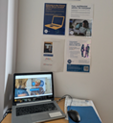 | Citizens Advice Wirral  We Are Citizens Advice - the people’s champion. We give people the knowledge and confidence they need to find their way forward - whoever they are, and whatever their problem. We are here to help everyone who needs it with practical advice you can really trust. Our national charity and network of local charities offer confidential advice online, over the phone, and in person, for free.  Phone: 0808 278 7848/0800 144 8848  Website: citizensadvicewirral.org.uk  Terminal: Visit our Citizens Advice Wirral self-help terminals located in reception areas. At the terminal you can find useful information, request email advice, get the telephone number to speak to an advisor, or request a call back.
 | The Whitechapel Centre  To prevent and resolve homelessness, social exclusion and housing poverty by providing practical, realistic, tailored support so that each person can find a route out of homelessness, maintain a home and achieve their individual potential. To be an excellent, high profile independent local charity working in partnership to see an end to homelessness, social exclusion and housing poverty in our communities.  Phone: 0151 272 5508  Website: www.whitechapelcentre.co.uk/wirral.html  Email: wirralteam@whitechapelcentre.co.uk
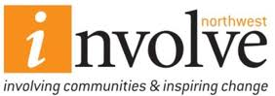 | Involve Northwest  We’re passionate, we’re driven, we’re dynamic and we’re there for you. We are Involve Northwest. Whether your focus is on returning to workplace, on seeking advice and guidance for your family or making positive steps to change your life, Involve Northwest can help.  Phone: 0151 644 4500  Website: www.involvenorthwest.org.uk  Email: info@involvenorthwest.org.uk

 | Compañeros  Compañeros is a safe community space for anyone struggling to cope in a crisis. They offer a calming environment, with experienced staff members on hand to support individuals aged 18+, who are experiencing a mental health crisis. A safe space, where people can talk openly, free from judgement or stigma. Access to one-to-one crisis support, wellbeing recovery projects, creative arts and essential social/emotional support.  Phone: 0151 488 8135  Website: www.spiderproject.org.uk/crisis-centres  Email: enquiries.comp@spiderproject.org.uk
 | Everyturn Mental Health  Our services offer a range of free NHS talking therapies, advice, information and support. Talking therapies can help you to understand and work through your difficult feelings and develop strategies for coping better. The best therapy will depend on your particular situation.  Phone: 0151 649 1859  Website: www.everyturn.org  Email: ccc.wirral@everyturn.org
 | Tomorrow’s Women Wirral  Tomorrow’s Women Wirral is a small Wirral-based charity that supports vulnerable women to make positive lifestyle changes. Many of the women are dealing with a range of issues including domestic abuse/violence, drug and alcohol misuse, depression and anxiety, mental health issues, learning difficulties, childcare/support issues or other social problems.  Phone: 0151 647 7907  Website: www.tomorrowswomen.org.uk  Email: admin@tomorrowswomen.org.uk
 | Wirral Mind  Wirral Mind is a local, independent mental health charity. We provide services to adults in our local community with mental health problems and learning disabilities. Our aim is to normalise the conversation around mental health, tackle stigma and discrimination, promote understanding and support our community to live mentally healthier lives.  Phone: 0151 512 2200  Website: www.wirralmind.org.uk  Email: learning@wirralmind.org.uk

 | Wirral Change  Wirral Change is an outreach service offering information, advice and guidance on jobs, education, training, self-employment, health and wellbeing, as well as signposting to other services for racial minority people on the Wirral.  Phone: 0151 649 8177  Website: www.wirralchange.org.uk  Email: info@wirralchange.org.uk
 | Wirral Multicultural Organisation  To actively support members of the local ethnic minority backgrounds by providing advocacy, social support and activities, assistance to access health and social care services, including advice and education services.  Phone: 0151 792 5116  Website: wmo.org.uk/  Email: info@wmo.org.uk
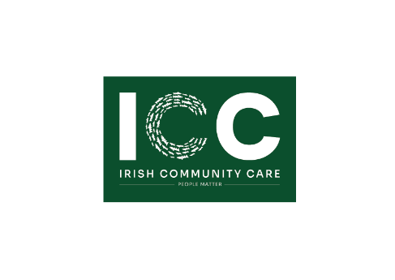 | Liverpool Irish Centre  We work with Irish, Irish by Descent/Heritage, Irish Traveller and Gypsy Traveller communities to build strength and resilience, break down barriers and change lives. We support with: Passport and Citizenship Applications, Welfare Benefits, Accommodation, Cost of Living Mental and Physical Health, Dementia, Substance Misuse, Domestic and Honour Based Abuse, Access to education, employment, prison release.  Contact details Phone: 0151 237 3987  Email: admin@irishcc.net www.irishcc.net;
 | Heart 4 Refugees  Our services are designed to help refugees fully integrate into our community, helping them to build new, successful lives and relationships. We offer English classes, hot food, gardening, art-based therapy, early years outreach support, playgroup, clothing, household items, and food hampers.  Email: enquiries@heart4refugees.org

 | Wirral Age UK  Age UK Wirral exists to promote the wellbeing of older people on the Wirral, helping to make later life a fulfilling and enjoyable experience.  Phone: 0151 482 3456  Website: www.ageuk.org.uk/wirralliverpoolsefton  Email: enquiries@ageukwirral.org.uk
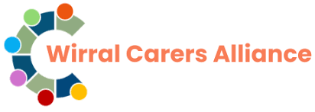 | Wirral Carers Alliance  We are Wirral Carers Alliance, a team of ‘Family & Friend’ carers and volunteers working in collaboration to ensure carers are included when improving the support available to communities on Wirral.  Website: www.wirralcarersalliance.com  Email: info@wirralcarersalliance.org.uk
 | Wired  The Wirral Carers Health and Wellbeing Service provides free support to adult carers (including parent carers and young adult carers in transition). The service focuses on identifying unpaid carers and supporting them to access services to assist them in their caring roll and to help them to maintain and improve their health and wellbeing.  Phone: 0151 522 7990  Website: www.wired.me.uk  Email: contact@wired.me.uk
 | Healthwatch Wirral  Healthwatch is your health and social care champion.  If you use health services or need care, we want to hear about your experiences. We can also help you find reliable and trustworthy advice and information.  Phone: 0151 230 8957  Website: healthwatchwirral.co.uk  Email: info@healthwatchwirral.co.uk

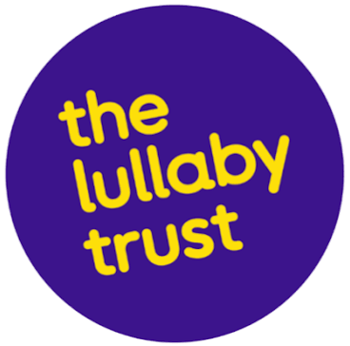 | The Lullaby Trust  The Lullaby Trust raises awareness of Sudden Infant Death Syndrome (SIDS) provides expert advice on safer sleep for babies and offers emotional support for bereaved families. We offer safer sleep for babies, and support for families.  Phone: 0808 802 6869  Website: www.lullabytrust.org.uk  Email: info@lullabytrust.org.uk
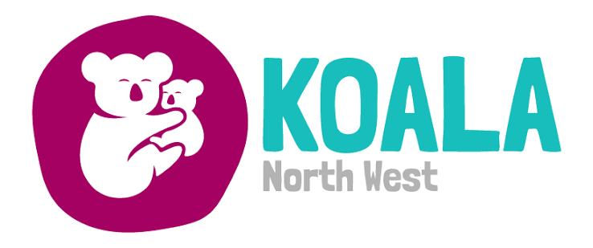 | Koala  Koala North West believes that every parent should have the support they need in order to give their children the best start in life. Our comprehensive range of services aim to work in partnership with parents by supporting and encouraging them through the difficulties of family life.  Phone: 0151 608 8288  Website: www.koalanw.co.uk  Email: admin@koalanw.co.uk
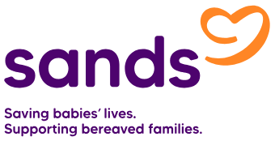 | Sands  Sands is a UK charity that works across the country to support anyone affected by the death of a baby; improve the care bereaved parents receive from health care and other professionals; and reduce the number of babies who do die by funding research and working closely with other organisations to create a world where fewer babies die.  Phone: 0808 164 3332  Website: www.sands.org.uk  Email: wirral@sands.org.uk
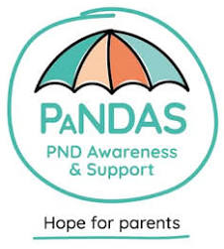 | PANDAS  We are here, whatever the weather, to offer hope, empathy and support for every parent or network affected by perinatal mental illness. PANDAS is a community offering peer-to-peer support for you, your family and your network.  Phone: 0808 196 1776  Website: www.pandasfoundation.org.uk

 | Wirral Women and Children’s Aid  We run a bright, friendly refuge for women and their children who need a place of safety. The refuge is a safe, comfortable home.  Phone: 0151 643 9766  Website: www.wwaca.org
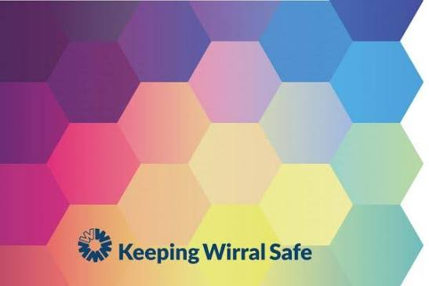 | ItsNeverOk  #ItsNeverOk offers a one-stop view of services across Wirral for domestic abuse support. It is open to anyone who may be experiencing or think they are experiencing domestic abuse, professionals supporting someone through domestic abuse, and if you are worried about a family member or friend.  Website: itsneverokwirral.org
 | Refuge  Domestic abuse and violence against women and girls will only end when we create gender equality. Refuge is committed to a world where domestic abuse and violence against women and girls is not tolerated, and where women and children can live in safety.  Phone: 0808 2000 247, freephone 24/7  Website: refuge.org.uk
 | Family Safety Unit  Wirral Family Safety Unit (FSU) is a team of Independent Domestic Violence Advocates (IDVA’s). The FSU provides independent and impartial advice to any high-risk victim / survivor of domestic abuse. We provide support to victims and their families who are experiencing domestic abuse. We also provide support for people experiencing or at risk from harmful practices; honour-based abuse and forced marriage.  Phone: 0151 666 4914

 | Autism Together  We host regular autism-related events and training opportunities for families, individuals and employers. These range from our regular Introduction To Autism and Behaviour workshops, to our monthly coffee mornings where families can get advice and support whilst socialising with other parents and carers.  Phone: 0151 334 7510  Website: autismtogether.co.uk
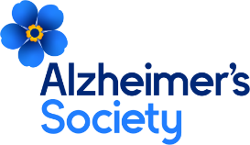 | Alzheimer’s Society  No matter what type of dementia you have, we’re here for you. Alzheimer's Society offers a range of support services. From a listening ear on the phone to a visit in person and opportunities to connect with others. We'll be there for you again and again and again, no matter what. If you need dementia support, we’re here for you.  Get personalised information, support and advice from the Dementia Support Line on 0333 150 3456  Website: www.alzheimers.org.uk
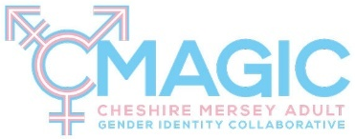 | CMAGIC  A new, free counselling service has been launched in Wirral for trans, non-binary and intersex residents. This is a vital service and can be accessed by a self-referral.  Website: www.cmagic.org.uk
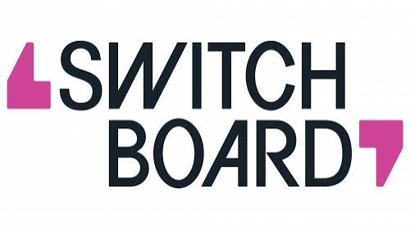 | SWITCHBOARD  We are Switchboard, the LGBTQIA+ Helpline. We are a safe space for anyone to discuss anything, including sexuality, gender identity, sexual health and emotional well-being.  Phone: 0800 0119 100  Website: switchboard.lgbt  Email: hello@switchboard.lgbt

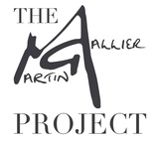 | The Martin Gallier Project  The Martin Gallier Project is fiercely dedicated to preventing suicides, breaking down stigmas and supporting families, including those bereaved by suicide, in the North West.  Phone: 0151 644 0294  Website: www.themartingallierproject.org  Email: admin@gallierhouse.co.uk

Hoarders Helping Hoarders

We are a network of peer groups based in Merseyside, Manchester, Lancashire and Cheshire.

Phone: 07921 814374
Website: hoardershelpinghoarders.com
Email: bringinghoarderstogether@gmail.com

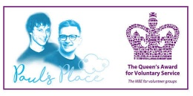  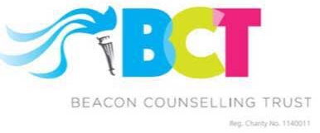 | Pauls Place  Paul’s Place Suicide Bereavement Support Programme offers a free specialist postvention bereavement counselling service, for those bereaved by suicide provided by Liverpool based charity Beacon Counselling Trust.  Phone: 0151 226 0696  Website: beaconcounsellingtrust.co.uk/get-support  Email: support@beaconcounsellingtrust.co.uk
 | WEB Merseyside  We support people who may feel isolated, victimised, marginalised, or overlooked.  Through listening, learning, and community connection, we help individuals reconnect with their worth and create the life they want, on their own terms.  Phone: 0151 653 3771  Website: webmerseyside.org  Email: info@webmerseyside.org

 | Wirral Ways To Recovery  Wirral Ways to Recovery is a free and confidential drug and alcohol service for adults (including offenders), young adults, families, carers and affected others in Wirral. CGL leads the Wirral Ways to Recovery partnership. We provide a range of treatment, recovery and support services for those who have concerns about their drug or alcohol use.  Phone: 0151 556 1335  Website: www.wirralways.org.uk  Email: wirral.services@cgl.org.uk
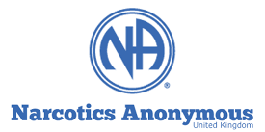 | UK Narcotics Anonymous  If using drugs is causing problems in your life NA can help. NA exists solely so that its members can support each other to stay drug free and to help others achieve and maintain a drug free recovery and lifestyle.  Phone: 0300 999 1212  Website: ukna.org
 | UK Cocaine Anonymous  Cocaine Anonymous is for men and women who share their experience, strength and hope so that they may solve their common problem and help others to recover from their addiction.  Phone: 0800 612 0225  Website: www.cocaineanonymous.org.uk  Email: helpline@cauk.org.uk
 | Drug Talk  Accessible drug and alcohol information for people from ethnic backgrounds living in Wirral.  Information available in over 100 languages.  Website: drugtalk.co.uk

 | Gamblers Anonymous - Birkenhead  Gamblers Anonymous is a fellowship of men and women who share their experience, strength and hope with each other so that they may solve their common problem and help others do the same. This site offers various aids for the compulsive gambler including a forum, a chat room, literature and most importantly a meeting finder.  Phone: 07974 668 999  Website: gamblersanonymous.org.uk  Email: info@gamblersanonymous.org.uk
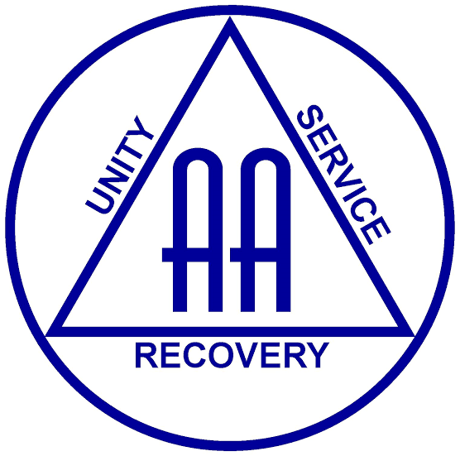 | Alcoholics Anonymous  Alcoholics Anonymous, or AA, is a community of people who come together with one aim: to stay sober and help other alcoholics seeking help to stop drinking.  Helpline: 0800 917 7650  Website: www.alcoholics-anonymous.org.uk  Email: help@aamail.org
 | MEN TOO  Men Too is a charity offering free support for a wide range of issues regarding men’s mental health and wellbeing. We are a community-based service provider that supports men with complex needs who may be isolated, victimised, discriminated against, have low self-esteem, and lack hope.  Phone: 0151 653 3771  Website: mentoomerseyside.org
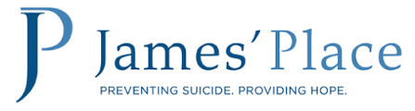 | James’ Place  We help men in suicidal crisis find hope for the future. We offer free, lifesaving treatment to suicidal men in Liverpool, London, Newcastle and Birmingham. We provide a safe, friendly, therapeutic environment in which men are cared for and respected.  Phone: 0151 303 5757  Website: www.jamesplace.org.uk  Email: liverpool@jamesplace.org.uk

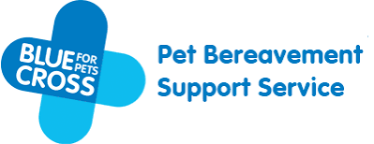 | Blue Cross  Grieving for the loss of a pet, whether through death, parting or enforced separation can be a sad and difficult experience. Volunteers respond to calls and emails on the support line every day. All have experienced the loss of a pet and have completed a training course. They offer a “listening ear” and give time, patience and encouragement to pet owners as they work through their loss.  Phone: 0800 096 6606  Website: www.bluecross.org.uk/pet-loss-support  Email: plsmail@bluecross.org.uk
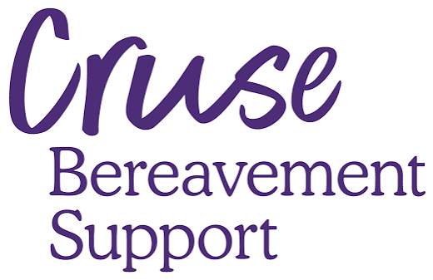 | Cruse Bereavement Support  Cruse in Wirral offers 1-1 support and bereavement support groups to adults aged 18 and over. Each of our branches offers a unique mix of support services that is tailored to their local area.  Phone: 0151 645 6604  Website: www.cruse.org.uk  Email: wirralarea@cruse.org.uk  You can also call our free phone National Helpline on 0808 808 1677
 | OCD Action  We provide support and information to anybody affected by OCD, work to raise awareness of the disorder amongst the public and front-line healthcare workers and strive to secure a better deal for people with OCD.  Helpline: 0300 636 5478  Website: ocdaction.org.uk
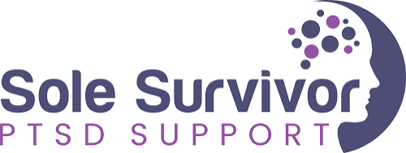 | Sole Survivor - PTSD Support  At Sole Survivor, we are here to help you through your PTSD journey and offer support in any way we can. Our mission is to offer a safe, professional and effective peer support service for people who are having trouble accessing mainstream trauma therapy or have not achieved the recovery they desire through traditional approaches.  Phone: 07903 544 585  Website: ptsdsupport.co.uk  Email: info@ptsdsupport.co.uk

 | Samaritans  You talk, we listen  We listen to you and help you talk through your concerns, worries and troubles.  Phone: 116 123  Website: www.samaritans.org
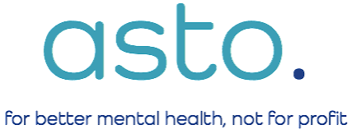 | Asto  Asto’s founder, Steve Turnock, has previously suffered from severe OCD and is aware of how life-changing the right support can be. Asto is a UK charity that was established in 2020 for the sole purpose of providing treatment based on what works for individuals suffering from OCD.  Phone: 02843 444 110  Website: www.astoclinics.com  Email: sue@astoclinics.com
 | Sahir House  We’ve been supporting our LGBTQ+ communities and people living with HIV across the Liverpool City with support when you need it most, offering practical and emotional assistance, as well as camaraderie and connection, in a safe, non-judgmental environment.  Phone: 0151 673 1972  Website: www.sahir.org.uk  Email: info@sahir.org.uk
 | RASA  RASA Merseyside is a professional counselling and support service that exists solely to improve the mental and physical well-being of individuals impacted by sexual violence at some point in their lives.  Phone: 0151 558 1801  Website: rasamerseyside.org  Email: rasa@rasamerseyside.org  Helpline: 0808 500 2222

 | A Better Life Wirral  We support people to reduce their smoking and break the habit. Research shows stopping can improve your health, mood and energy levels  Phone: 0151 541 5656  Website: ablwirral.co.uk  Email: cmicb-wi.ablwirral@nhs.net  iOS Stubit app  Android Stubit app
 | Wirral Brough Council  Council Switchboard: 0151 606 2000  Monday to Friday 9- 5  Adult Social Care: 0151 606 2006  Children’s Social Care: 0151 606 2008  Out of hours emergency: 0151 677 6557  Website: www.wirral.gov.uk
 | EPP  We offer support and advice with energy bills, grants & fuel debt, reduce home energy usage & improve efficiency.  Phone: 0800 043 0151  Website: www.epplus.org.uk  Email: advice@epplus.org
 | Wirral Lifelong Leaning Service  We aim to help adults to get the skills they need for a job, volunteer, or get ready for work. We offer a range of high-quality qualifications and community learning courses.  Phone: 0151 666 3330  Website: courses.wirralglobal.net  Email: lifelonglearning@wirral.gov.uk

 | Wirral WEN  Wirral Environmental Network is a local charity which hosts a wide range of events such as gardening, clothes swap, climate emergency training.  Phone: 0151 639 2121  Website: wirralenvironmentalnetwork.org.uk
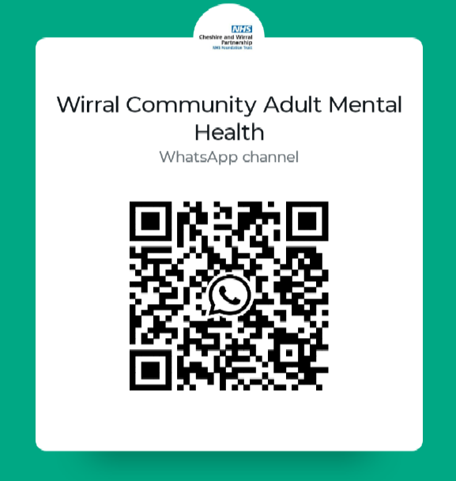 | CWP Adult Mental Health  Follow the Wirral Community Adult Mental Health Channel on WhatsApp for information, news on events in your community and wellbeing tips.  Scan the QR code and follow the channel.  Followers cannot see each other's phone numbers.  Following a channel is private and is not shown to other followers.
 | Children and Young People's Mental Health Services (CYPMHS)  We provided services that support young people up to age 18 with their mental health and emotional wellbeing. Services generally support young people experiencing:  - low mood or depression  - feelings of worry or anxiety  - problems with eating, or your relationship with food  - self- harm/ thoughts of suicide  - difficult feelings after a traumatic event  Website: www.mymind.org.uk
 | Charlotte’s Brightside  Charlotte’s Brightside charity was founded in memory of Charlotte Churchill, who died tragically in a car accident. We have a weekly timetable of actives and support for the local community based in Wallasey  Phone: 0151 630 2626  Website: https://www.charlottesbrightside.org  Email: charlottesbrightside2011@gmail.com

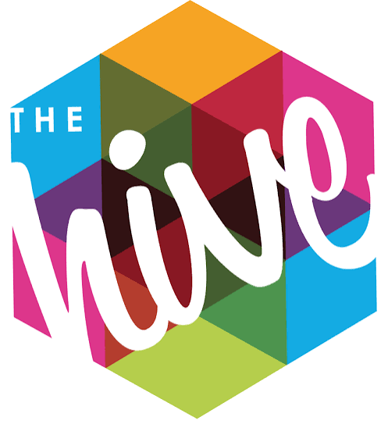 | The Hive  Let's Work It Out Support group for 13-19 years (up to 25 with additional needs) who are LGBTQ+ and/or questioning their sexuality and gender. The group itself is confidential, if you wish to attend please contact us on the email address below to arrange an induction.  Phone: 0151 705 8000  Website: www.thehiveyouthzone.org  Email: enquiries@thehiveyouthzone.org
 | Branch  Everyone has ups and downs in their mental wellbeing. Branch is here to support the children and young people of Wirral find the support that works for them.  Website: https://branch-wirral.co.uk
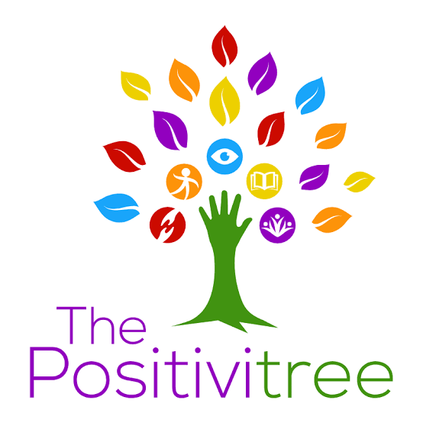 | The Positivitree  The Positivitree is a Wirral based social enterprise that works with families who have children with disabilities, special educational, medical or mental health needs. We work to enable parents and carers to look after their personal health and wellbeing, which in turn enables easier access to services that support their child’s needs.  Phone: 0151 458 8033  Website: thepositivitree.com  Email: admin@thepositivitree.com
 | Comics Youth  We offer a range of creative services designed to support and amplify the voices of marginalised young people aged 8 - 25. From zine creation and comic book reading workshops to youth-led publishing hubs.  Phone: 07983 464 702  Website: comicsyouth.co.uk  Email: hi@comicsyouth.co.uk

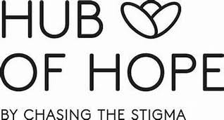 | The Hub of Hope  The Hub of Hope is the UK’s leading mental health support database. It is provided by national mental health charity, Chasing the Stigma, and brings local, national, peer, community, charity, private and NHS mental health support and services together in one place.  Website: hubofhope.co.uk  iOS app  Android app
 | Smiling Mind  Practice your daily meditation and mindfulness exercises from any device.  Smiling Mind is a unique tool developed by psychologists and educators to help bring balance to your life.  Website: www.smilingmind.com.au  iOS app  Android app
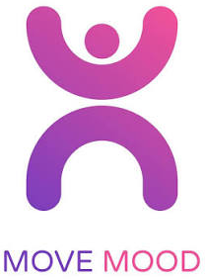 | Move Mood  Move Mood is an app developed for teenage mental health charity stem4 and uses the evidence-based treatment Behavioural Activation Therapy to help improve mood by encouraging increased motivation.  Website: https://movemood.stem4.org.uk  iOS app  Android app

Useful websites and apps

 | Sleepio  Sleepio is a 6-week online program designed by sleep experts and based on cognitive and behavioural techniques.  Website: www.sleepio.com
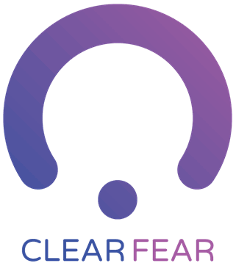 | Clear Fear  About Clear Fear, the fear of threat, or anxiety, is like a strong gust of wind. It drags you in and makes you want to fight it or run away. Instead, face your fear with the free Clear Fear app and learn to reduce the physical responses to threat as well as changing thoughts and behaviours and releasing emotions.  Website: clearfear.stem4.org.uk  iOS app  Android app
 | Kooth  Kooth is commissioned by the NHS, Local Authorities, charities and businesses to provide anonymous and personalised mental health support for Children and Young People.  Website: www.kooth.com
 | MoodMission  MoodMission is an evidence-based app designed to empower you to overcome feelings of depression and anxiety by discovering new and better ways of coping.  Website: moodmission.com  iOS app  Android app

 | Todoist  Achieve mental clarity by sorting tasks into Today, Upcoming, or using custom filters. See only what you need, when you need it.  Website: www.todoist.com  iOS app  Android app
 | MindShift CBT  MindShift CBT uses scientifically proven strategies based on Cognitive Behavioural Therapy (CBT) to help you learn to relax and be mindful, develop more effective ways of thinking, and use active steps to take charge of your anxiety. A new feature, the community forum, now enables you to find and offer peer-to-peer support.  Website: mindshiftcbt.com  iOS app  Android app
 | Calm  Calm is the #1 mental health app designed to help you manage stress, sleep better, and live a happier, healthier life.  Website: www.calm.com  iOS app  Android app
 | Qwell  Adults accessing Qwell can do so without the waiting lists or thresholds often associated with traditional services. They can join online peer support communities, access self-help materials or engage in drop-in or booked one-to-one online chat sessions with our experienced counsellors.  Website: www.qwell.io

 | Bearable  Quick and easy symptom tracking for any chronic health issue or disorder. Discover what improves and worsens your symptoms so that you can find better ways to manage your health and well-being.  Website: bearable.app  iOS app  Android app
 | MoodKit  Most mood trackers hand you a chart and call it a day. MoodKit studies your own check-ins and tells you, plainly, which activities lift you up, which drag you down, and what to try next.  Website: moodkit.co  iOS app
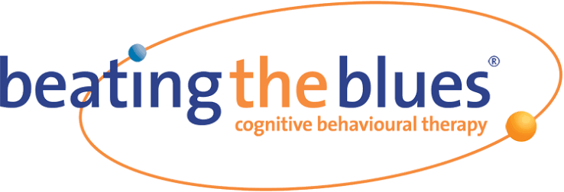 | Beating The Blues  Beating the Blues is an online Cognitive Behavioural Therapy (CBT) program for individuals with mild to moderate depression and anxiety. This online CBT course enables users to work through modules to learn about and apply the principles of CBT at a time and place to suit each individual.  Website: www.beatingtheblues.co.uk
 | Suicide Safety Plan  Suicidal thoughts can seem like they will last forever – but these thoughts and feelings pass with time. This app is designed to support those dealing with suicidal thoughts and help prevent suicide.  Website: https://suicidesafetyplan.app  iOS app  Android app

Veteran information

 | The Royal British Legion  The Royal British Legion is at the heart of a national network that supports our Armed Forces community. We’re here through thick and thin, ensuring their unique contribution is never forgotten. Our support starts after one day of service and continues through life, long after service is over. From providing expert advice and guidance, to recover and rehabilitation, through to transitioning to civilian life, we can be by their side every step of the way. And it’s not just members of the Armed Forces but their families too.  Phone: 0808 802 8080  Website: www.britishlegion.org.uk
 | Project Nova  Op NOVA, delivered by the Forces Employment Charity and commissioned by NHS England, provides support for veterans who are in contact with the justice system, enabling them to access the services they need.  Phone: 0800 917 7299  Website: www.forcesemployment.org.uk  Email: opnova@forcesemployment.org.uk
 | Combat Stress  We provide specialist treatment and support for veterans from every branch of the military and theatre of operation, focusing on those with PTSD, Complex-PTSD, and moral injury resulting from their experiences during military service.  Phone: 0800 138 1619  Text: 07537 173 683  Website: combatstress.org.uk  Email: helpline@combatstress.org.uk

 | SSAFA  SSAFA, the Armed Forces charity is a trusted source of support for serving personnel, veterans and their families in their time of need.  SSAFA helps the armed forces community in a number of ways, though our focus is on providing direct support to individuals in need of physical or emotional care.  Phone: 0800 260 6780  Website: https://www.ssafa.org.uk
 | The Poppy Factory  The Poppy Factory helps veterans and their families to make progress on the path to employment.  The people we support can face some of the most challenging situations in the Armed Forces community.  Each year, our specialist team helps hundreds of people to feel heathier, more independent and better connected.  Phone: 0208 940 3305  Website: www.poppyfactory.org  Email: support@poppyfactory.org
 | Valour  VALOUR connects veterans and their families to the services, people and organisations that understand your experiences.  Whether it’s critical help or simply a listening ear, use VALOUR to find the right support options for you.  Phone: 0808 1914 218  Website: valour.campaign.gov.uk  Email: DBSAFVS-VSTriage-Team-National@mod.gov.uk

Notes

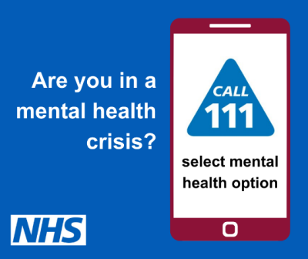
The Stein Centre
St Catherine's Hospital
Derby Road
Birkenhead
CH42 0LQ

Phone: 0300 303 3157
Website: www.cwp.nhs.uk

The information contained in this booklet is accurate to the best of our knowledge at the time of publication. Information may change over time, and readers should verify any details before relying on them.

